**Term Projects: Telephone Handset Housing**

**DEPARTMENT OF MECHANICAL AND INDUSTRIAL ENGINEERING**

by

**NATHAN ROBINSON**

Group Partner: Alexander, David

**Instructor : Dr. Kwabena A Narh**

**ME 470-001 Properties of Plastics**

**Fall 2016**

Date Submitted: 12/12/2016





**Table of Contents**

Abstract 2

Introduction 3

Design Process 4

Evaluation of Design 5 – 10

Optimization of Design 11 – 12

References 13

Appendix 14

**Abstract**

This report contains a detailed evaluation of an injection molding simulation created using the CAE software Autodesk Simulation Moldflow Advisor 2015. The evaluation and optimization was done for a mold design of a telephone handset, a specific material selection process, gate location suitability analysis as well as a few heat calibration analysis were made and presented with data and images from the software according to the mold design in order to display the entire injection molding process regarding mechanical properties, fill time, deformations and potential cost.

**Introduction**

**Project Objectives**

The main objectives of this project are to create, evaluate, record and present the set up regarding the injection molding process for a telephone handset housing mold design. As well as then optimize the evaluation in order to potentially obtain the best possible injection molding process.

**Description of Product Functions**

The telephone housing handset has a simple function, to retain and protect the electronic system that will be inside of it once the telephone is assembled.

To achieve it’s function there are several desirable features regarding the final product that can be pointed out such as high enough density for good rigidity and low cost.

**Design Process**

**Material selection**

The two top kinds of resin considered for this injection mold are ABS (Acrylonitrile Butadiene Styrene) standard medium-impact Lustran® 248 and HDPE.

By using a browser material comparison tool form Vanderveer Industrial Plastics a handy evaluation can be seen of these two types of plastics. An image of the snapshot taken from the website can be seen below and is referenced below the figure description.

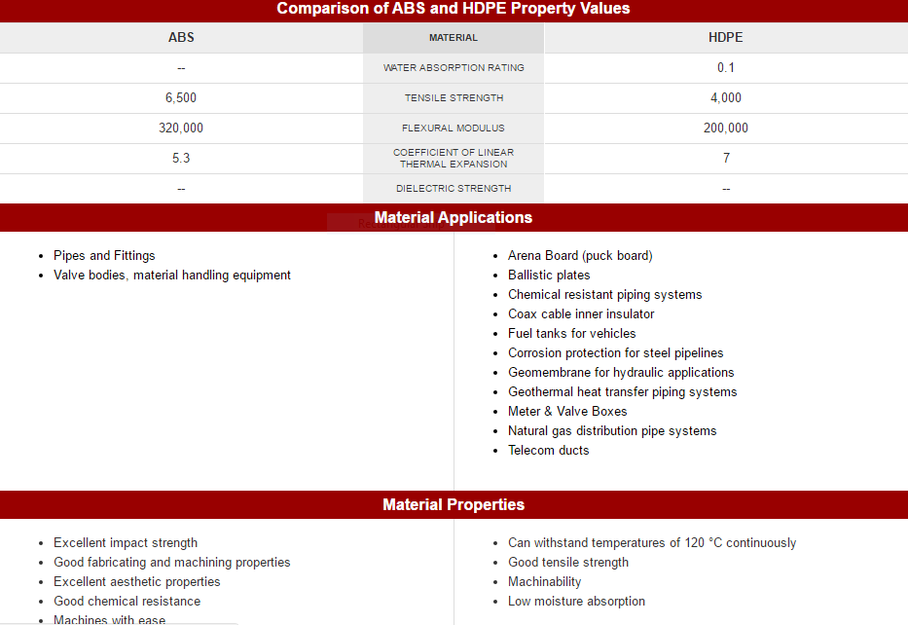

**Fig 1; Snapshoot taken from Vanderveer Industrial Plastics Material Selection Tool**

**http://www.vanderveerplastics.com/compare-materials.html?sel1=abs-machined-parts&sel2=hdpe**

According to this comparisonthe standard ABS has a higher tensile strength and flexural modulus and a lower coefficient of linear thermal expansion, meaning that the final product created using ABS will have stronger desired properties such as rigidity, and also the injection of the resin will have less warpage and shrinkage due to the lower coefficient of linear thermal expansion.

Thus choosing the ABS (Acrylonitrile Butadiene Styrene) standard medium-impact Lustran® 248 over HDPE seems to be the better option.

Lustran® 248 is a multi-purpose resin which offers a good balance of mechanical properties. Luckily a plastic research and manufacturing company named INEOS STYROLUTION provides in good faith a highly detailed ASTM technical data sheet for Lustran® 248. Please refer to this reports appendix where the data sheet is attached further information on Lustran® 248.

**Evaluation of Design**

1. **Gate Location**

Autodesk Simulation Moldflow allows the user to obtain a recommendation image showing where the location of the injection gate would be most suitable, as shown in the figure below.

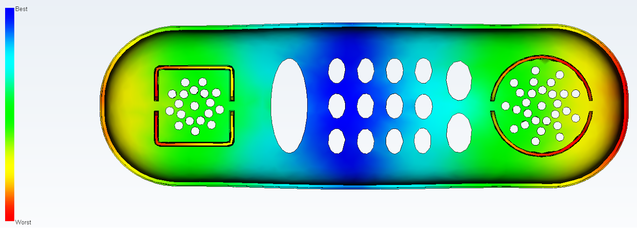

**Fig 2; Gate suitability analysis**

The center of the mold appears to be the most suitable area for the gate location, and the for ends appear to be the least optimal according to the analysis, and thus a gate located in the center will be used for the initial evaluation of the mold design.

**ii) Fill Time**

The fill time refers to the amount of time it takes for the injected resin to completely fill the mold cavity, with the gate located at the center an analysis shows a max fill time of 2.007 seconds, which is pretty good due to the gate location being in the middle, as seen in the figure below.

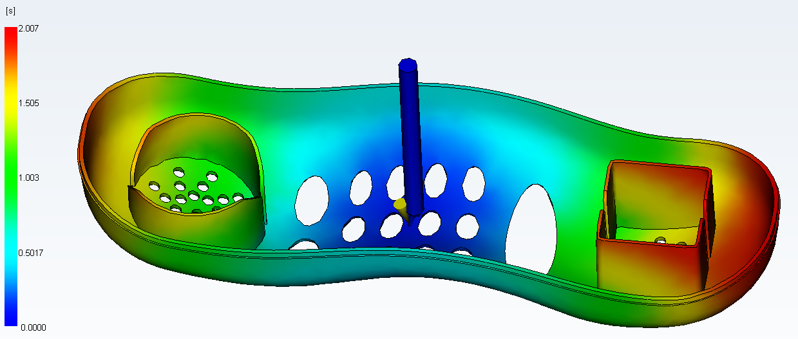

**Fig 3; Fill time analysis**

1. **Confidence of Fill**

In order to make sure that entire mold cavity will be able to fill with resin a confidence of fill analysis is made and shown below.

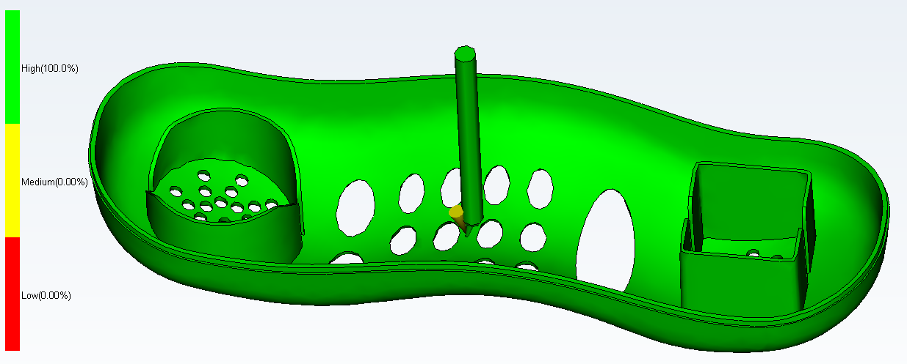

**Fig 4; Confidence of fill analysis**

The analysis seems to display a confidence of 100% that the cavity will be filled if the injection mold were to be executed with this current set up.

1. **Weld Line Locations**

The weld line locations can affect the functionality of the entire part. By creating a weld line analysis with the current gate location it can be seen that the weld lines tend to be pointing outward and thus if the housing were to fracture at some point these weld lines could very well guide the cracks being created toward the outer edges thus causing total part failure. An image of the analysis can be seen below.

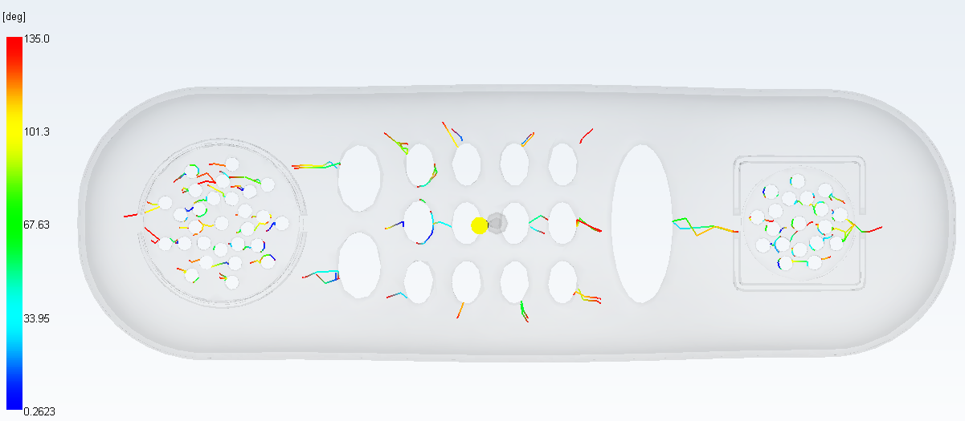

**Fig 5; Weld line analysis**

1. **Air Trap Locations**

Due to the cavity shape several air traps are formed while the resin is filling the mold. The location of these air traps can predicted by creating an air trap location analysis, this can be seen below.

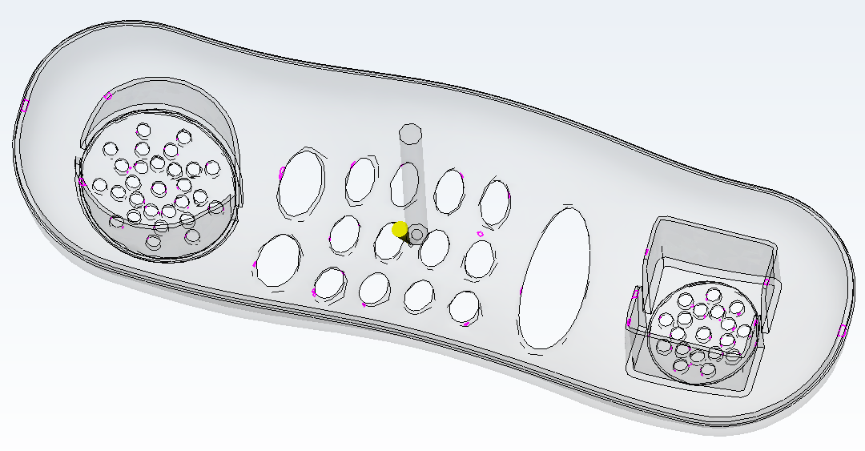**Fig 6; Air trap analysis**

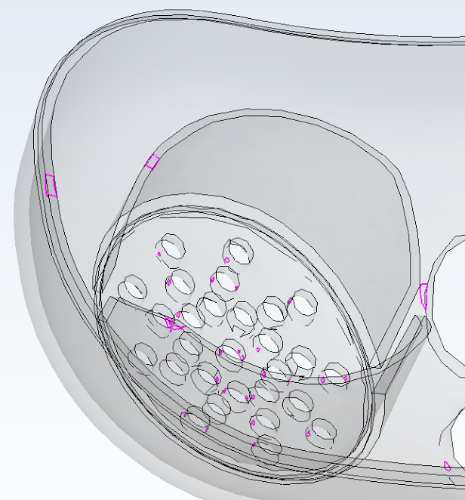 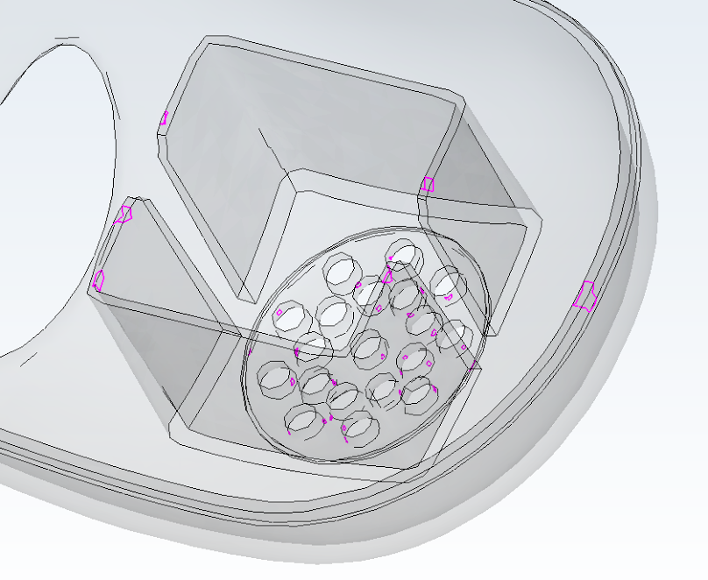

**Fig 7; Air trap analysis close up #1 Fig 8; Air Trap analysis close up #2**

These kinds of air traps are normal in injection molding processes and for this kind of mold design it would difficult to say if a change in gate location would make the final product better or worse regarding air traps.

1. **Skin Orientation**

The skin orientation simply describes the direction and path the resin is traveling in order to fill the mold cavity, for this design the skin orientation can be seen by creating a skin orientation analysis, seen below.

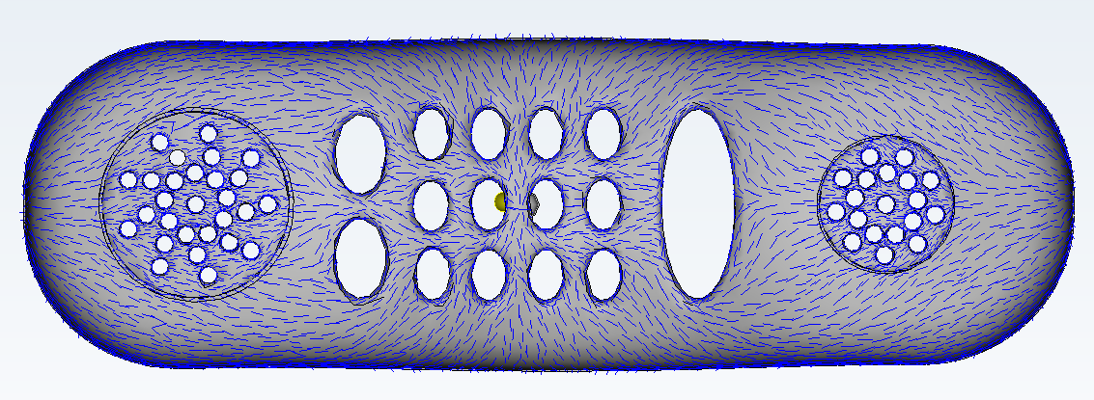

**Fig 9; Skin orientation analysis #1**

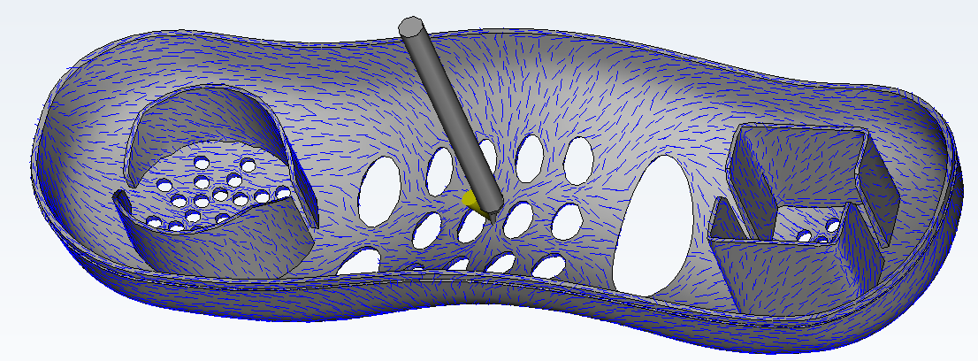

**Fig 10; Skin orientation analysis #2**

The current skin orientation seems to flow toward the outer edges which in effect also causes the weld lined to form in the same direction, this could possibly be optimized by changing the gate location.

1. **Part Shrinkage**

Before the part shrinkage can be evaluated a cooling circuit must be created in order to run the analysis, for the entirety of this process a cooling circuit running 70% ethaline glycol and 30% water is used, an image of the created cooling circuit is shown below.

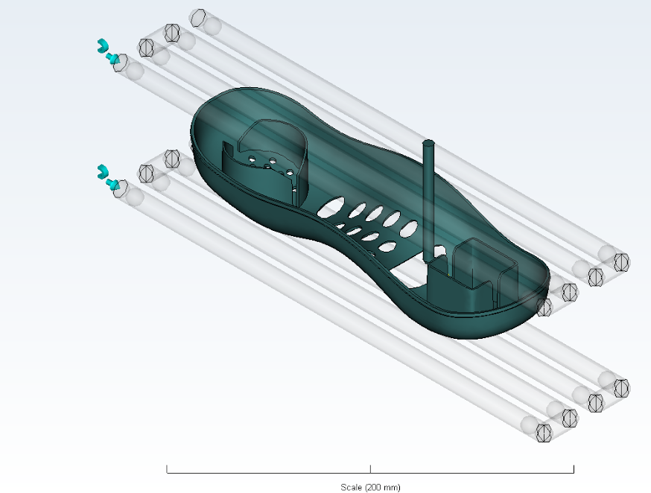

**Fig 11; Cooling circuit being simulated**

Due to temperature differences between the mold and the resin, there is shrinkage of the part while inside the cavity when being cooled; a shrinkage analysis shows an evaluation of the part shrinkage.

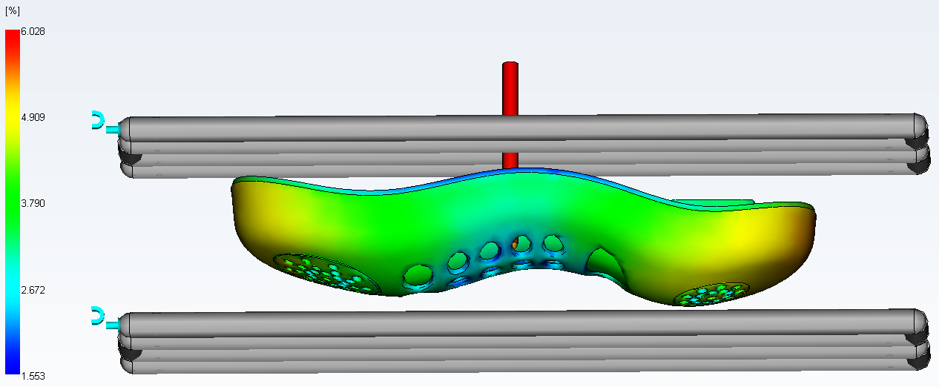

**Fig 12; Shrinkage analysis**

1. **Part Warpage**

The part warpage is also caused be temperature differentials during the injection molding process; this mold design seems to have extremely low percent warpage, the part warpage analysis is shown below.

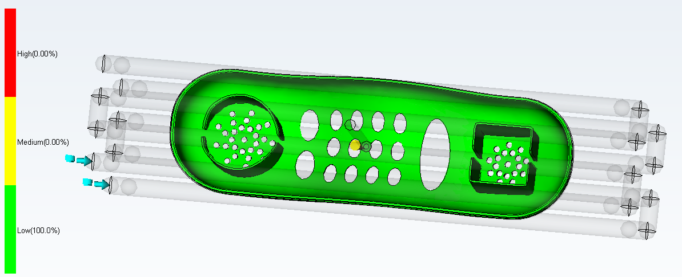

**Fig 13; Warpage analysis**

**Optimization of Design**

**Weld Line Optimization**

A change in the gate location would change the skin orientation thus changing the weld line location and creating a more fail-safe product as can be seen by a new chosen a new gate location seen below.

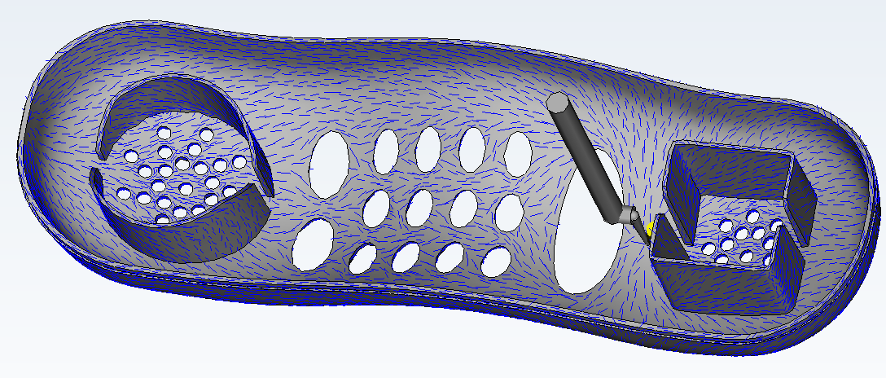

**Fig 14; Optimized gate location skin orientation analysis #1**

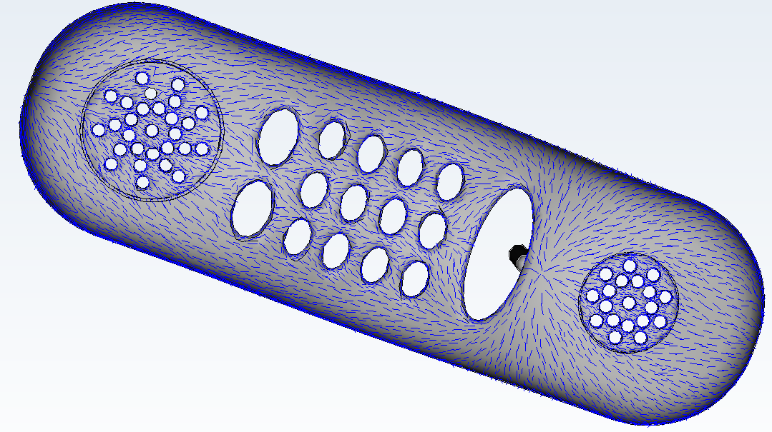

**Fig 15; Optimized skin orientation analysis #2**

It can be observed that the skin orientation is now running along the longer edge toward the further end of the cavity similar to a river flowing down a stream instead of outward toward the sides like the previous gate location incited.

Consequently the weld lined will also reform in a different manner as can be seen in the analysis below.

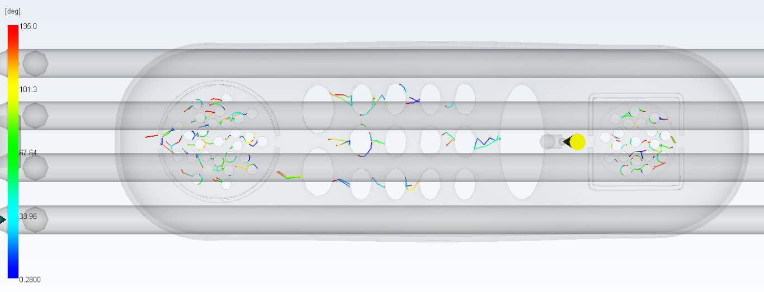

**Fig 16; Optimized weld line analysis**

As predicted the weld lines can be observed to no longer point outward towards the edges of the but rather a more horizontal path along the cavity thus helping to prevent a potential fracture to reach the outer edges.

**Bad Gate Location**

An example of a bad gate location optimization can be seen in the weld line analysis shown below. It shows another set of weld lines that could be inconvenient in case of future fracture.

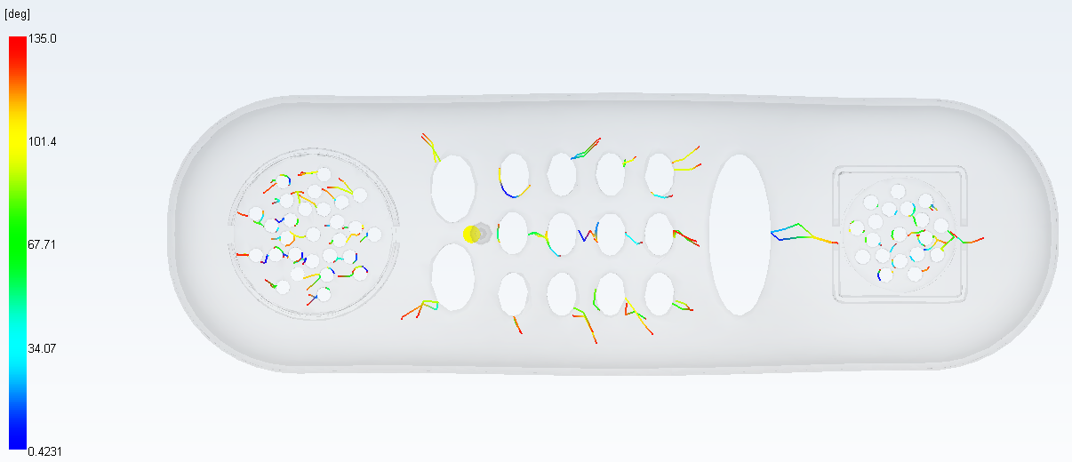

**Fig 17; inconvenient gate location and weld line analysis**

**References**

**Material comparison tool:**

http://www.vanderveerplastics.com/compare-materials.html?sel1=abs-machined-parts&sel2=hdpe

**Technical data sheet for Lustran® 248:**

https://www.ineos-styrolution.com/Product/Lustran-Standard_Lustran-248_SKU300600421201.html